**CREATING A SERVICE INSTANCE**

➔ First, Register and Login in your IBM cloud Account.

➔ Click on Catalog

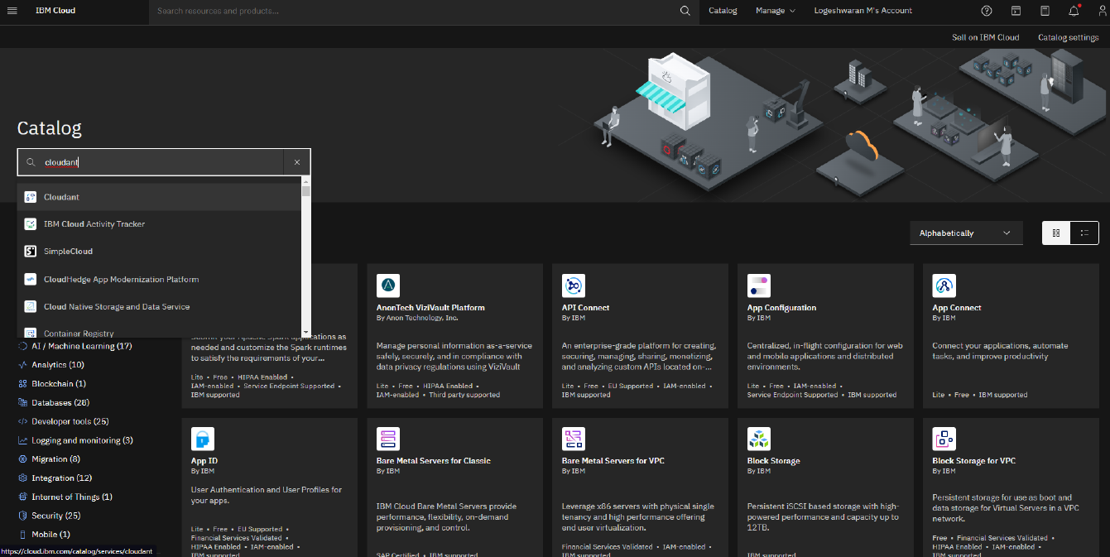

➔ Type Cloudant in the Search bar and Click on Open it.

➔ Select an Offering and an environment.

➔ Select region as Dallas and Type an instance name then click on create

service.

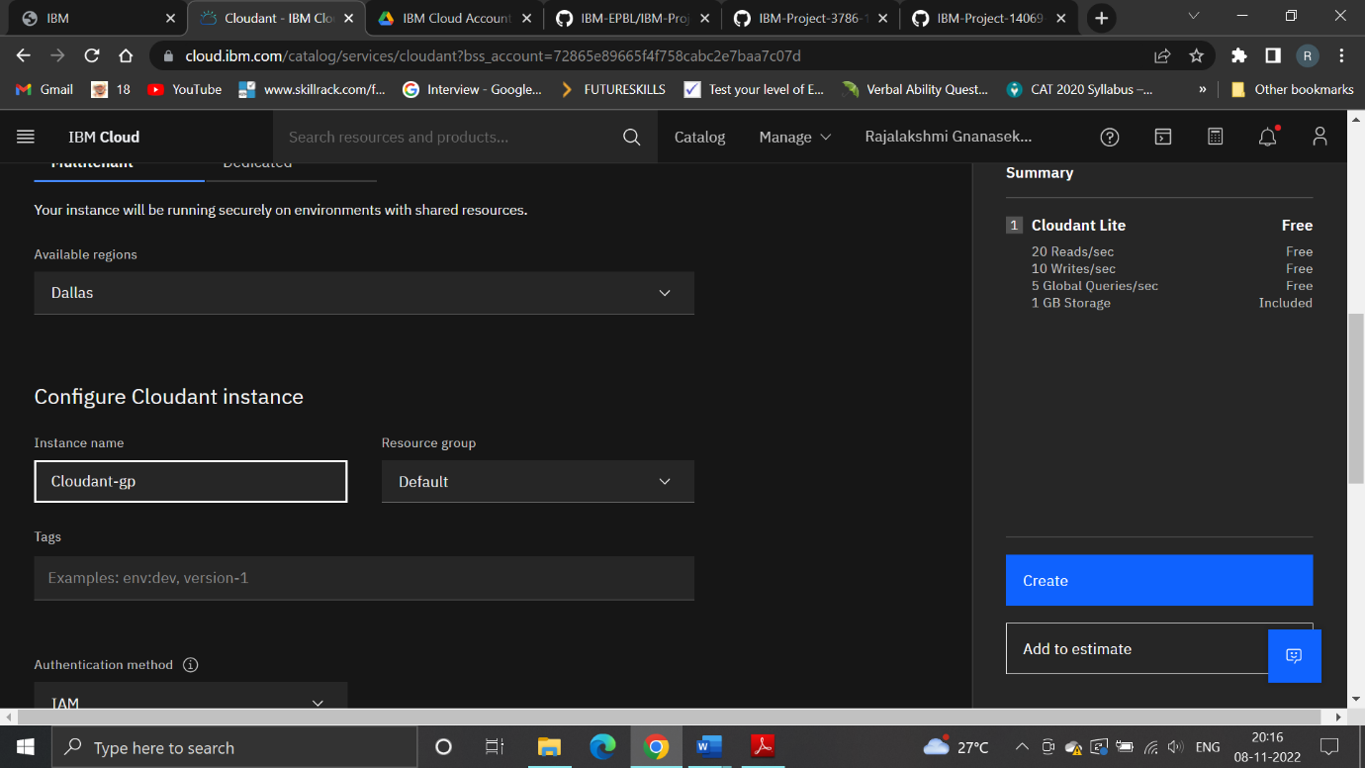

➔ After you click create the system displays a message to say that the

instance is being provisioned, which returns you to the Resource list.

From the Resource list, you see that the status for your instance is,

Provision in Progress.

➔ When the status changes to active, click the instance

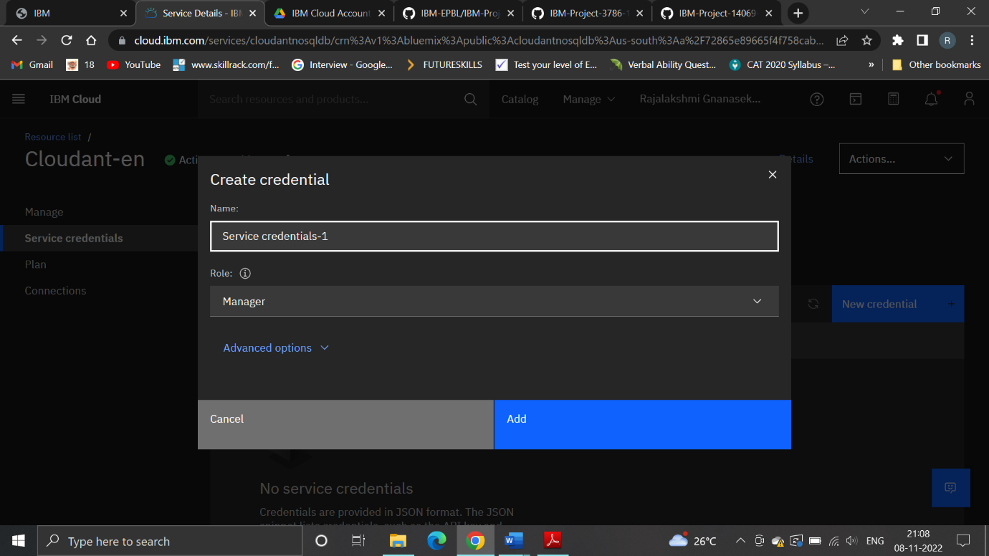

➔ The data is created and the service credentials are available

